**Issue and its solution while setup selenium+ eclipse+ Cucumber**

1. **IE browser is not open and in console the error is**

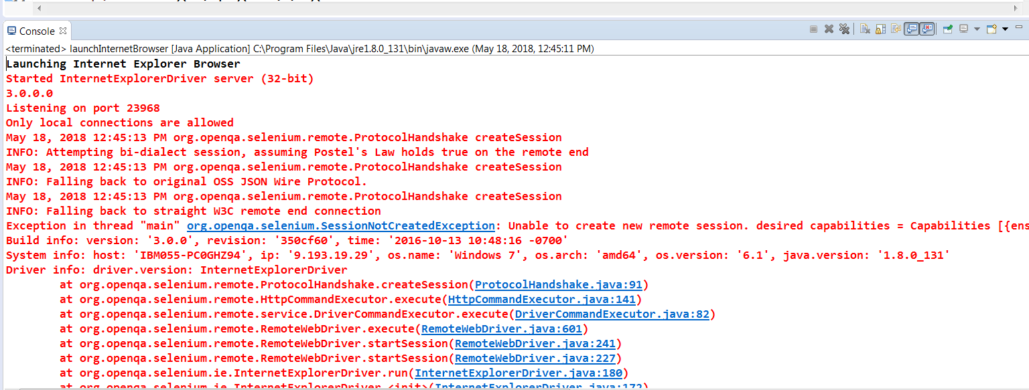

**Solution:**

Go to IE browser- Tools- Internet Options- Security tab- Select each zone and make the checkbox “Enabled Protected Mode” enabled for each zone ( Internet /Local internet/ Trusted sites/ Restricted Sites)

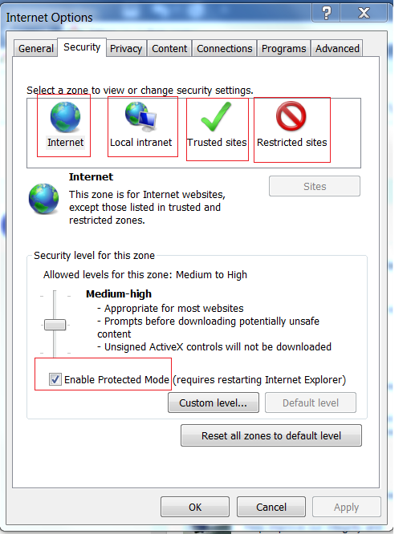

Run the program. It will work

1. **IE browser is open but any URL is not accessible**

**Solution:**

Go to settings- make Zoom 100% and run the program. It will work